# -include cover page, indicating name, date, made using unity (version)

# Introduction

This is a project that I have done with Udacity that provides me an opportunity to create a Virtual Reality Simon Says puzzle mobile application using Unity.

# Outcome

The game has been finalised after several rounds of iterations using feedback from different users.

Simon Says Puzzler is about following the sequence of the Orbs displayed in the dungeon. The user has to complete the Puzzle in order to escape the dungeon and will be given an option to play again at the end of the game.

# Story of the process

Prior to development of the game, it is essential to identify the targeted audience. I have decided to target people who are new to VR. During the process, I have created a Persona for my audience as ‘group of people who are new to Virtual Reality (VR) and interested to experience VR’.

This would mean that the environment should be comfortable and easy to experience. Which resulted in the mood setting of the scene, Mysterious. I should also avoid movement in the scene to reduce the chance of the user encountering simulation sickness, thus making the game more safe and enjoyable.

The sketches below, allowed me to reduce time spent on modifying my designs in unity.

## Sketches of VR Puzzler Project:

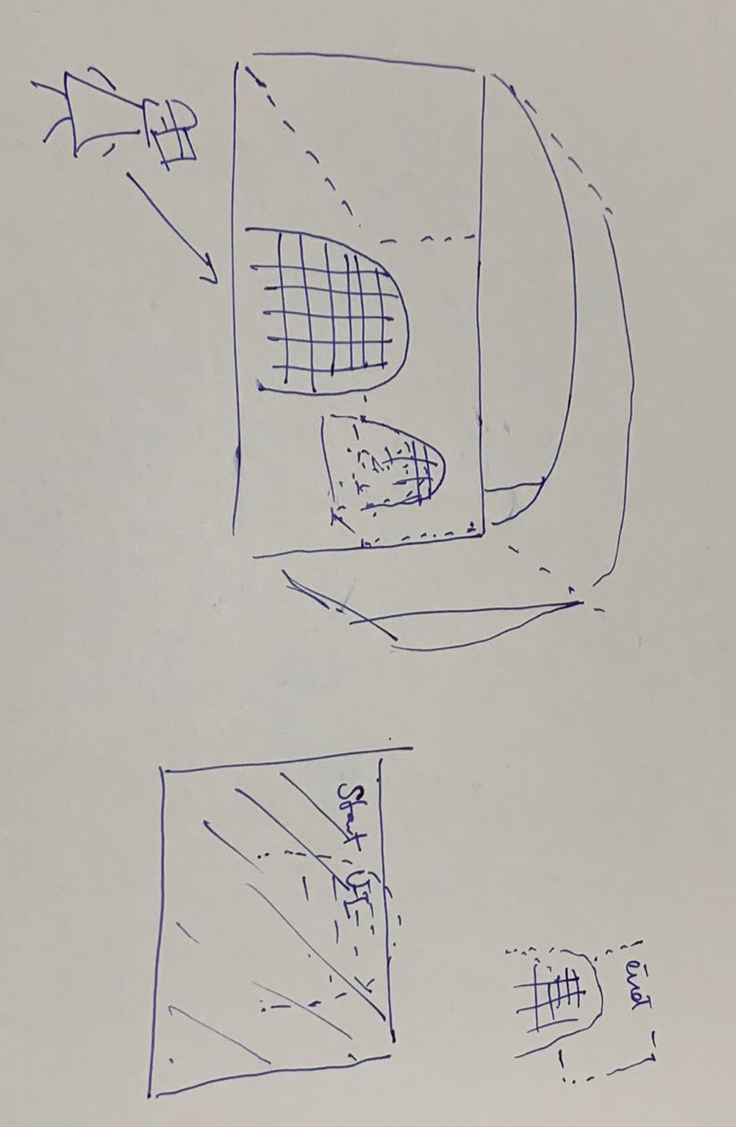

Figure 1: Overview of dungeon outline

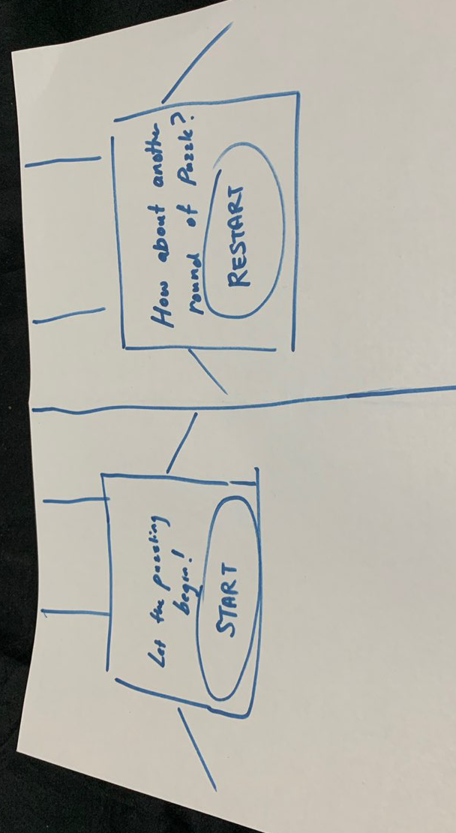

Figure 2: User Interface (UI) Elements

Moving forward, I created a build from scratch; setting the scale and scene, defining a graphical user interface, adding audio and visual feedback. Testing it out with different users, allowed me to gain insight with what could be improved in the game. Several iterations were made until the quality of the game is acceptable.

# User testing outcomes and iteration

|  |  |
| --- | --- |
| **User Remarks (Test #1)** | **Screen** |
| The skybox in the scene is too lively and draws the mood away from being mysterious. | Figure 3: My first scene |
| Despite my scene being bright, the actual gameplay on my Mobile is very dim. The lights emitted from the torches are barely visible as seen in the next two screens. | Figure 4: Scene from unity    Figure 5: Gameplay on Mobile    Figure 6: Gameplay #2 on Mobile |
| Iteration #1:  Light emitted from the torches have been adjusted to have a greater intensity. | Figure 7: Updated light intensity from torches |
| Iteration #2:  Setting a dark and more mysterious environment using a different skybox. | Figure 8: Adjusted Skybox |

|  |  |
| --- | --- |
| User Test #3 | Me: How was the mood of the environment?  User: Eerie.  Me: Imagine yourself as the person in the dungeon, is the size of the gate relative to a door in real life?  User: Door is quite small. It looks like a window.  Me: Is it comfortable for you to select the Orbs? Do you feel that you are moving too much or perhaps straining your neck?  User: Yes. The balls are quite far apart, it would be better for them to be in circle.  Other feedback:   1. The light emitted from the torches is brighter below than the top. 2. It would be nice if the game could have its ‘RESTART’ button located right in the center of the screen. So when I complete the puzzle, I don’t have to move my head to reach the button. 3. UI is a little big. |
| Iteration #3: Adjusting size of barrel to make the gate/doors look bigger.  Iteration #4: Adjusted orbs to be static and arranged them in a circle.  Iteration #5: Adjusted range of Point Light to match torches.  Iteration #6: Adjusted position of Restart UI to match Pointer when user completes the puzzle. | Figure 9: Downsized barrels |
| Final outcome | Figure 10: End User Interface    Figure 11: Final look inside the dungeon. |

# Breakdown of final piece

After several iterations, I have decided to set the mood of the environment to be mysterious and eerie by changing the tint of the skybox to dark red. This provides an intense experience and urges the user to quickly escape the dungeon. I have also increased the volume of the background sound to 1.0, instead of 0.25 as it was on the soft side. By re-using the ‘MoveTo’ function from the iTween script, I was able to create a move dynamic experience when the User selects ‘RESTART’ after completing the puzzle.

Video of my project: https://youtu.be/b7SdRmF2FP8

# Conclusion

I found this project to be a good starting point for those who would like explore VR. It is easily accessible by anyone who owns a smartphone. In addition, Simon Says is easily known by many and the Simon Says Puzzler provides a familiar concept to the game. This game also allows the user to experience movement and interaction with other objects in Cardboard VR.

From the developer’s perspective, I have noticed many discrepancies while running the project in Unity on Desktop and Cardboard Mobile VR. Therefore as a best practice, the game should always be tested on mobile device to achieve accurate results.This project has also stressed the importance of iteration through User Feedback which allows the quality of the game to be improved using different designs. Furthermore, the project requires me to explore different technical aspects of VR, such as attaining the correct Cardboard profile for my mobile device. As a result, I have a noticed a limitation on my Redmi 5 Plus (model of mobile device) which results in the cardboard lens appearing more ‘square-ish’ than other mobile devices while running VR.

Lastly this project gives me an opportunity to present my work to my future employer.